Action Verbs (Dynamic Verbs)

🔹 What is Action Verbs (Dynamic Verbs)
# Source: AI Source: Provided by: [Data Path: Persons Table -> ID Column: 1, Name_En Column: Motasem Essam] -> From: [Chatgpt (GPT-4-turbo)] on [7/27/2025]
An action verb (also called a dynamic verb) is a verb that shows an action — either physical or mental — that the subject is doing.

✅ Definition:
# Source: AI Source: Provided by: [Data Path: Persons Table -> ID Column: 1, Name_En Column: Motasem Essam] -> From: [Chatgpt (GPT-4-turbo)] on [7/27/2025]
An action verb expresses something that a person, animal, or thing does (physically or mentally).
It answers the question: What is the subject doing?

🧍‍♂️ Two Main Types of Action Verbs:
# Source: AI Source: Provided by: [Data Path: Persons Table -> ID Column: 1, Name_En Column: Motasem Essam] -> From: [Chatgpt (GPT-4-turbo)] on [7/27/2025]
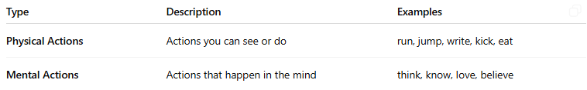
Type | Description | Examples
Physical Actions | Actions you can see or do | run, jump, write, kick, eat
Mental Actions | Actions that happen in the mind | think, know, love, believe

📚 Examples in Sentences:

🏃 Physical Action Verbs:
# Source: AI Source: Provided by: [Data Path: Persons Table -> ID Column: 1, Name_En Column: Motasem Essam] -> From: [Chatgpt (GPT-4-turbo)] on [7/27/2025]
- He runs every morning.
- I wrote a letter.
- She kicked the ball.

🧠 Mental Action Verbs:
# Source: AI Source: Provided by: [Data Path: Persons Table -> ID Column: 1, Name_En Column: Motasem Essam] -> From: [Chatgpt (GPT-4-turbo)] on [7/27/2025]
- I believe you.
- She understands the lesson.
- We remembered his birthday.

✅ Characteristics:
# Source: AI Source: Provided by: [Data Path: Persons Table -> ID Column: 1, Name_En Column: Motasem Essam] -> From: [Chatgpt (GPT-4-turbo)] on [7/27/2025]
- They can be used in different tenses:
  - Present: He drives fast.
  - Past: He drove fast.
  - Future: He will drive fast.
- They can be transitive (take an object) or intransitive (no object):
  - Transitive: She reads a book.
  - Intransitive: He sleeps peacefully.

❌ Not Action Verbs:
# Source: AI Source: Provided by: [Data Path: Persons Table -> ID Column: 1, Name_En Column: Motasem Essam] -> From: [Chatgpt (GPT-4-turbo)] on [7/27/2025]
Be careful not to confuse linking verbs (like is, seem, become) with action verbs — those express a state, not an action.

✅ Summary:
# Source: AI Source: Provided by: [Data Path: Persons Table -> ID Column: 1, Name_En Column: Motasem Essam] -> From: [Chatgpt (GPT-4-turbo)] on [7/27/2025]
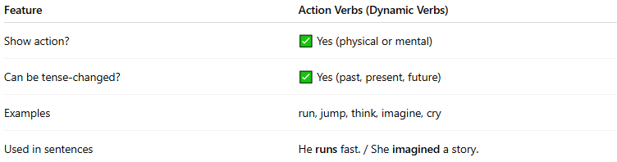
Feature | Action Verbs (Dynamic Verbs)
Show action? | ✅ Yes (physical or mental)
Can be tense-changed? | ✅ Yes (past, present, future)
Examples | run, jump, think, imagine, cry
Used in sentences | He runs fast. / She imagined a story.

